**1. What is Software ? What is Software Engineering ?**

* Software refers to a set of instructions or programs that tell a computer how to perform specific tasks.
* other programs that enable users to interact with hardware and perform various functions on a computer and device.
* **What is software engineering**
* Software engineering is the application of systematic, disciplined, and quantifiable approaches to the development operation, and maintenance of software .

**2. Explain is types of software . ?**

* Software can be broadly categorized into three types
* {1} **system software** : this includes operating systems ( like windows , mac OS, Linux ) and utility programs that manage computer hardware and provide a platform for other software to run .
* **{2} APPLICATION SOFTWARE :** these are programs designed to perform specific tasks for users, such as word processors , web browsers , games, and business application like accounting software .
* **(3) UTILITY SOFTWARE :** these are tools that help maintain and manage computer resources , such as antivirus programs, disk cleanup tools, and backup software .

**3. WHAT IS SDLC ? EXPLAIN EACH PHASE OF SDLC ?**

**(1) Planning:** This phase involves gathering requirements, defining the project's scope, and conducting feasibility studies. It sets the foundation for the entire project.

**(2) Analysis :** In this phase, detailed requirements are gathered and analyzed. This involves understanding the needs of the stakeholders and creating detailed functional specifications.

**(3) Design :** The design phase transforms the requirements into architecture and design specifications.

**(4) implementation :** Developers write the code based on the design documents. This phase is where the actual software is built.

**(5)Testing :** The software is rigorously tested to identify and fix defects. This ensures the product meets the required standards and works as intended.

**(6) Deployment :** The software is deployed to the production environment where users can start using it. This phase may involve installation, configuration, and user training.  
  
**(7) Maintenance :** deployment, the software is maintained to fix bugs, update features, and ensure its performance over time. This phase continues as long as the software is in use.

**(4). WHAT IS DFD ? CREAT A DFD DIAGRAM ON FLIPKART .?**

* A Data Flow Diagram (DFD) is a graphical representation used to visualize the flow of data within a system, showing how data is processed and transferred between different processes, data stores, and external entities**.**
* **DIAGRAM NO FLIPKART**

DED LEVEL =0

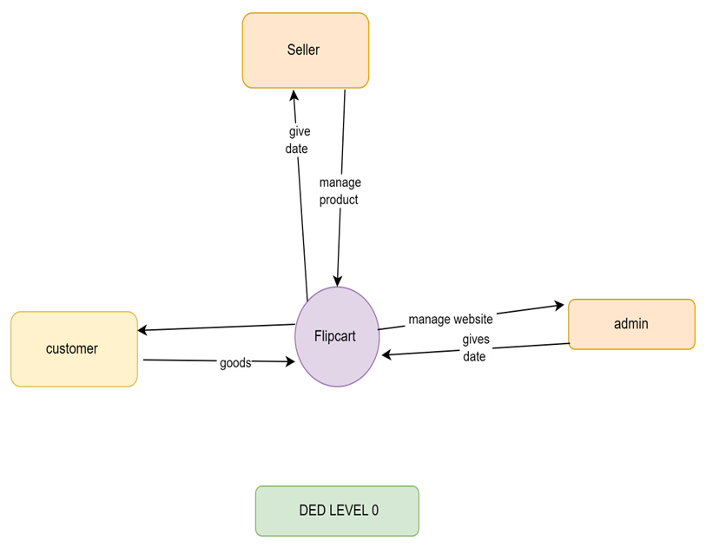

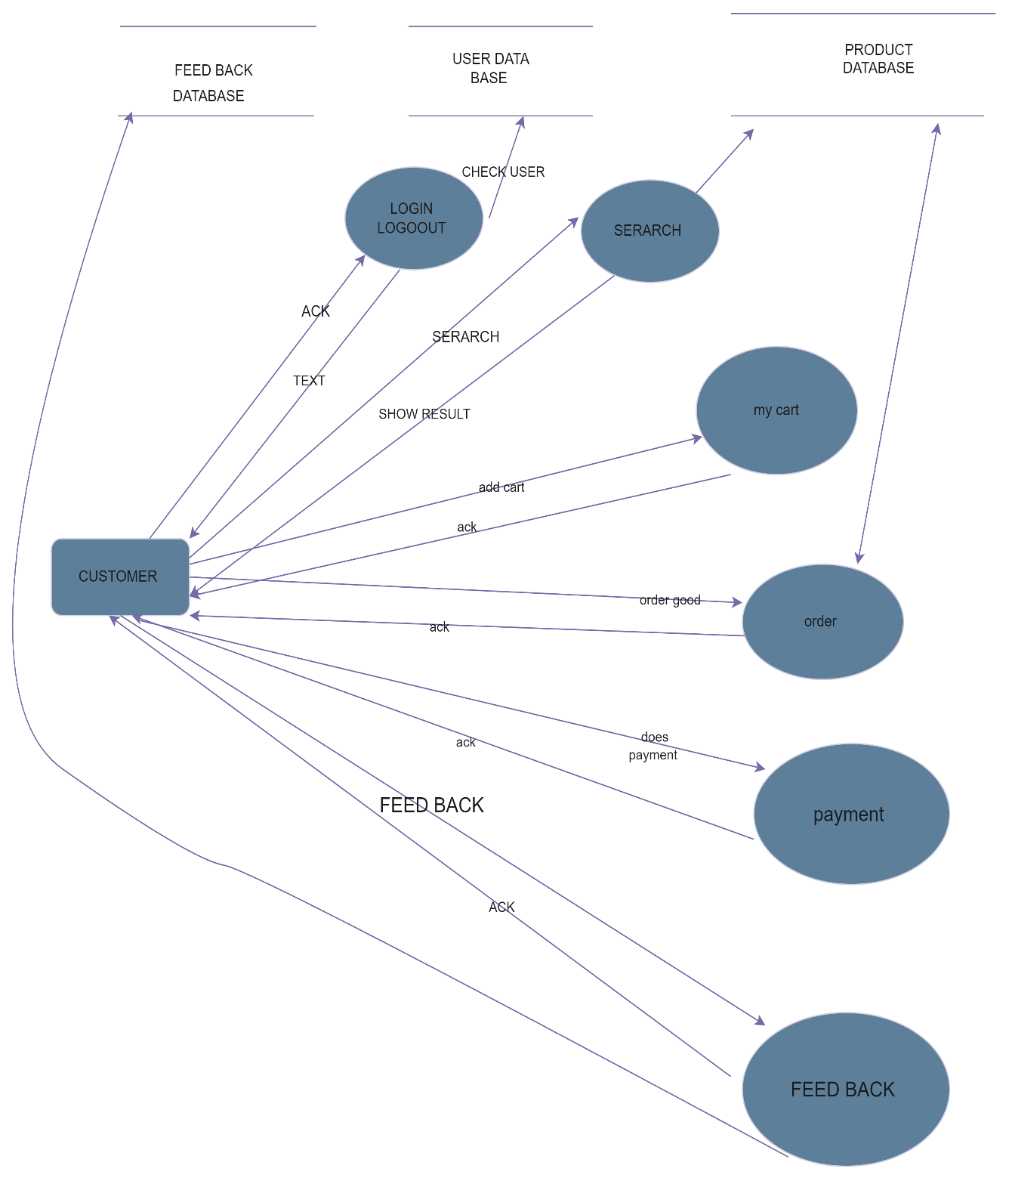

DFD LEVEL = 1

DFD LEVEL = 2

# 

**(5) WHAT IS FLOW CHART ? CREAT A FLOWCHART TO MAKE ADDITION OF TWO NUMBER .**

* A flowchart is a visual representation of a process or workflow, using symbols like arrows, rectangles, diamonds, and ovals to depict the sequence of steps, decisions, and actions.

**CREAT A FLOWCHART ADDITION OF TWO NUMBER**

. 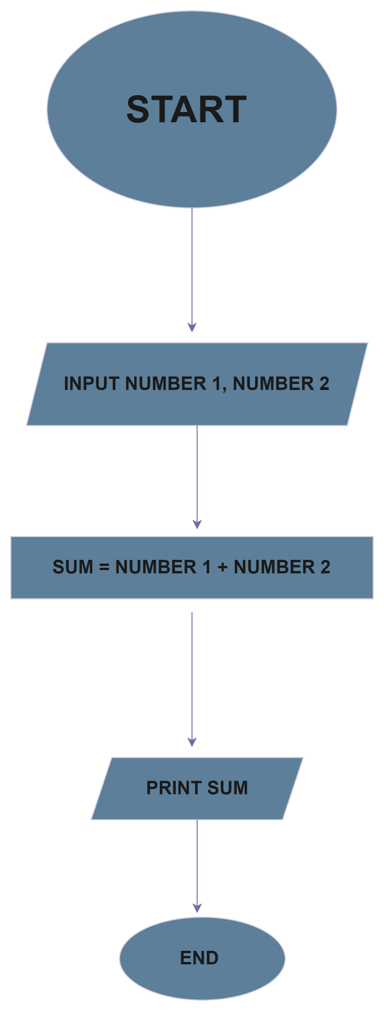

**(6) . What is Use case Diagram? Create a use-case on bill payment on paytm**

